Peter Every House

Short breaks for children and
Young people with
Disabilities

_{Guide for Parents and Carers}

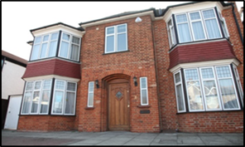

Revised September 2017

About us

Peter Every House service is for children and young people with learning difficulties, sensory impairments and disabilities who are aged from 8-18 years old.

Peter Every House was registered by Ofsted 1st of August 2017 as a provider to support children and young people with learning difficulties sensory impairments and disabilities who are aged from 8-18 years old.
However Ravensbourne project has been supporting children and young people with disabilities in Lewisham since 1977, Running a day service which started in 2000 supporting children from 8 -18 years.

Mission statement
Peter Every House belongs to you, the staff will listen to you so can have choices, fun activities and chances to learn new things in a safe way.
Peter Every House will work in partnership with families, carers and professionals, so that every children and young person will be valued as an individual, afforded dignity and respect and empowered to reach their full potential.

Staff at Peter Every House have the right to work without fear of violence of any nature. Aggression will not be tolerated and may result in your child’s short break service being withdrawn.
Respect statement

How it works
We accept referrals via the Children with Disabilities / Complex Needs team in Lewisham who are based at Kaleidoscope.

Should they feel a place at Peter Every House short breaks would be suitable you will be given an annual allocation that starts from the 1st April and ends on the 31st March each year. You can make your requests for short breaks on the booking letter or email / phone call. Booking letters that will be sent to you every three months. Bookings are usually done up to 3 months in advance and must be made up of booking for overnight stays during weekends term time and holidays.

the process includes:

- Referral from short break team via the children with disabilities/complex team at Lewisham.
- Placement match/impact risk assessment

- Visit to look around

- Support Needs Assessment

- Child/young person visits as many times as they need

- Child/young person stays overnight

- Parent/ carer books other stays

If you do not complete the booking form by the stated deadline your short break dates may be made on your behalf

Allocations are not carried over from one year to the next.

Children and young people have as many visits until they and their parents feel they are ready for their first overnight.
This only happens with your agreement.

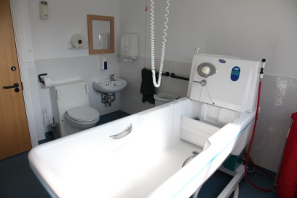

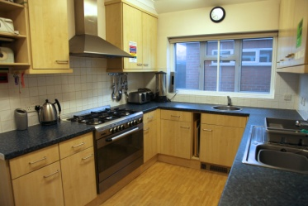
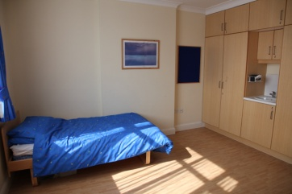
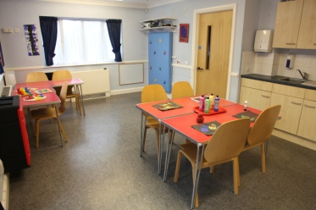
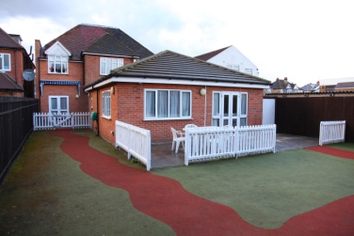
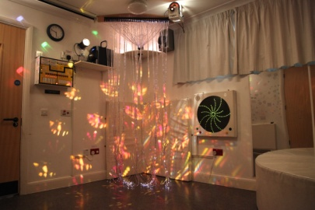
NOTHING ABOUT ME WITHOUT ME
Assessments / Care planning
Our aim at Peter Every House short breaks is to create a safe and welcoming environment where children and young people can relax, interact with each other and have fun.

In order for us to achieve this we like to gather as much information as possible about the young person prior to their first stay. We recognise as the parent/carer you and your child are the best person to speak to in order to gain information how to best meet the needs of your child.

The Support Needs Assessment is an important part of the assessment process. The information gathered will form part of the Placement Plan.
The Placement Plan identifies how the needs of your child are met and is read by all staff who work with your child at Ravensbourne short breaks.

You and your child will be sent a copy of the Placement Plan and it will be continuously monitored and updated to suit each young person’s changing needs.

bath or shower?
bedtime?
things I like?
what makes me angry?
sleep with light on?
medicine? favourite foods?
Allergies
What makes me happy
dislikes

might ask

Keyworker
Your child will be allocated a member of staff- a Key Worker, the link person who will ensure your child’s Placement Plan is up to date.

The Key Worker will also speak with your child’s school to see how their needs can best be met at Ravensbourne short breaks. Your child’s Key Worker will help to ensure your child has a smooth transition to Ravensbourne short breaks and a consistent level of care during stays.

What is there to do?
The emphasis at Peter Every House short breaks is on fun, and the service we provide is driven by the young people who visit us.

Our facilities include:
- Specialist equipment
- Mini bus for trips out
Laptops, IPAD, Xbox
- Toys and play equipment

We are able to cater for a wide range of dietary requirements and provide a varied, balanced diet throughout the week that is tailored to each young person.

Out and about
Visits to the local community and further afield form an important part of the service we provide, giving young people the chance to take part in activities that otherwise may not be accessible to them. We have a fully licensed minibus with hydraulic lift and wheelchair access and following a full risk assessment, provide trips out for young people during stays.
Staff can only drive this bus after they taken a driving test.

Visits and days out have included:
- Various sea side trips
- Woburn Safari park
- Leeds Castle
- City air port
- Cinema trips
- Residential weekend away
- Sailing activity

- T

Disabled Access
- Keypad security access to corridors
- Hoist systems and high needs beds
- 1 standard bathroom/1 fitted wheelchair accessible bath
- Shower and toilet chairs
- Lift access to first floor

Working together
medication
Once your child has been accepted for a stay at Ravensbourne short breaks we ask for your help with the following to ensure everything runs as smoothly as possible.
If your child is prescribed medication(s) is it important that you send medication that is labelled properly.

Medication must arrive in its original container, stating the name of the child, time(s) medication should be given, dosage, strength and expiry date.

You will also be asked to sign a medical information and consent form. These forms will have to be signed every 3 months or when changes arise.

We cannot dispense medication unless it corresponds with pharmacy label.
Please keep medication in its original container.

Children will not be accepted at Ravensbourne short breaks unless they have all their daily medications as prescribed by their GP.

clothing
Please provide enough clothing for your child’s staying including toiletries, pads and any other essential items your child requires. It would be helpful if you could label your child’s clothing and possessions.

complaints
We take all forms of complaint very seriously. You do not have to wait until your child’s review to raise any concerns. You can contact any member of staff at Peter Every House short breaks at any time. If further action is required the management team will contact you to explain how it has been addressed.

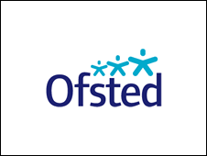

Children’s Home Regulations

Our practice is governed by legislation the most recent being the Children’s homes regulations April 2015 these include
The quality and purpose of care
The children’s views wishes and feelings
The education standard
The enjoyment and achievement standard
The health and well-being standard
The positive relationships standard
The protection of children standard
The leadership and management standard
Engaging with the wider system management standard
9.The Care planning standard
OFSTED inspect and regulate the care of children and young people throughout England and Wales.
The summary of an inspection stated that provided was:
“A good standard of care to the children who use the service. The staff create a nurturing environment in which children feel secure. Management is strong and ensures that the work done focuses on the wellbeing of the children who use the service.”

To view the full version of the report, contact Ofsted on 08456404045 or visit www.ofsted.gov.uk

Staff at Peter Every House@ Ravensbourne
‘My daughter didn’t go anywhere before she was referred for short breaks. She has very delicate needs and I didn’t think I would be able to let her come… But I was struggling and decided to give it a try. Now we feel so well supported by the staff that she comes for a weekend about once a month. She has become much more independent since she started coming. Peter Every House has given me my life back as I have freedom from the constant care that my daughter needs. It gives me extra time to spend with my other children.’
Mum of one of our Young People.
Staff who work at Ravensbourne Short breaks will have completed training in
- Safeguarding / child protection
- First aid
- Fire safety
- Food hygiene
- Competency to administer medication
- Communicating with children and young people
- Moving and handling
And many others in order to meet the needs of the children and young people in their care

Ravensbourne Project take recruitment and selection of staff very seriously. We only employ staff once they have gone through our rigorous 5 part interview processes
We actively encourage parents and children to take part in our recruitment and selection processes.

Peter Every House Short breaks

contact us
Ravensbourne Project
Peter Every House
4 Crantock Road
Catford SE6 2QT
Tel 0208 695 2661

Osareme@ravensbourneproject.org.uk
Sharon@ravensbourneproject.org.uk
Robert@ravensbourneproject.org.uk

Visiting
Once your child stays overnight you are of course welcome to visit. Where possible, it is best to avoid our busy times which are meal times and times when personal care tasks are being undertaken, such as later in the evening. Please feel free to telephone at any time during your child’s stay if you have any concerns or wish to speak with a member of staff.

